**Task 1**

**Question#1**

**(A)**

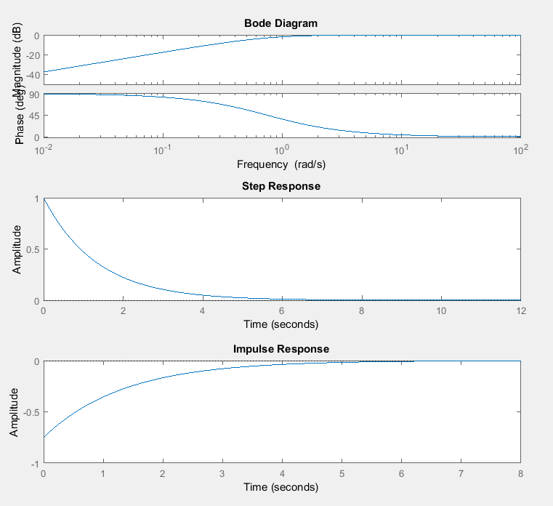

num = [4 0];

den = [4 3];

sys = tf(num,den);

subplot (311)

bode(sys)

subplot (312)

step(sys)

subplot (313)

impulse(sys)

**(C)**

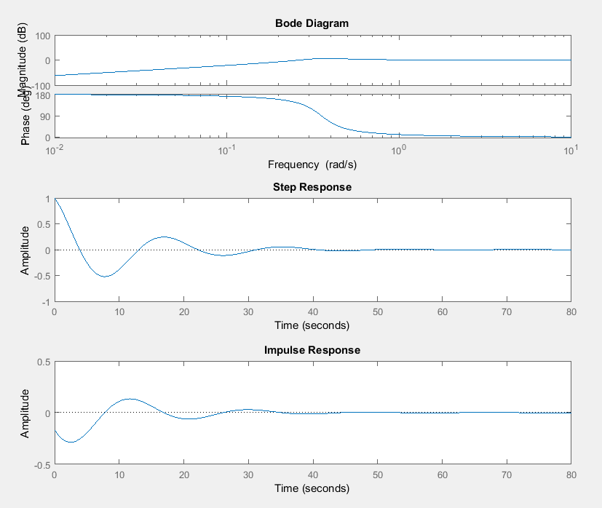

num = [24 0 0];

den = [24 4 3];

sys = tf(num,den);

subplot (311)

bode(sys)

subplot (312)

step(sys)

subplot (313)

impulse(sys)

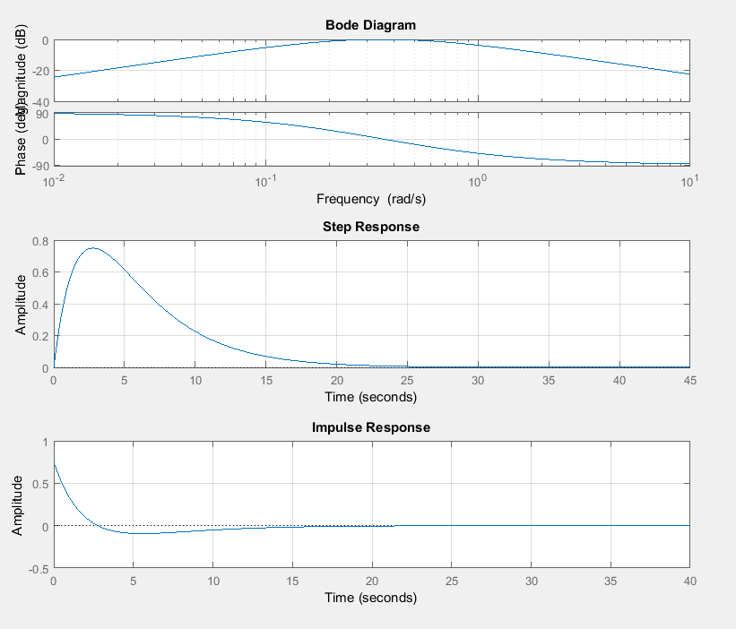**(D)**

num = [6 0];

den = [8 6 1];

sys = tf(num,den);

subplot (311)

bode(sys)

grid on

subplot (312)

step(sys)

grid on

subplot (313)

impulse(sys)

grid on

**Question#2**

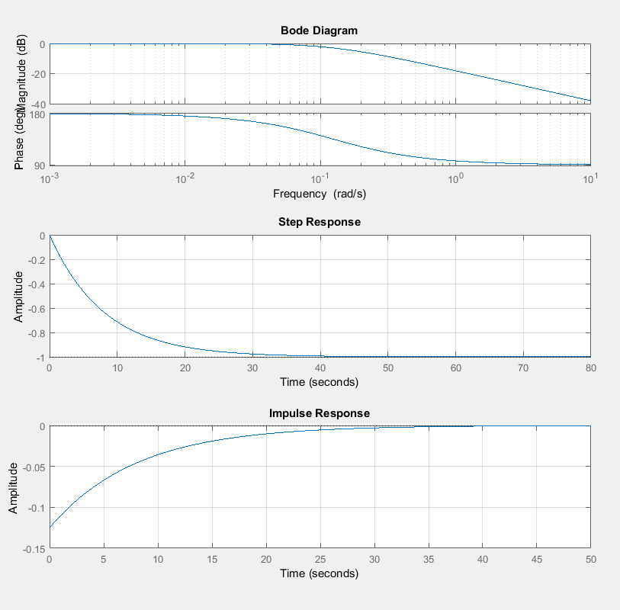**(C)**

num = [-1];

den = [8 1];

sys = tf(num,den);

subplot (311)

bode(sys)

grid on

subplot (312)

step(sys)

grid on

subplot (313)

impulse(sys)

grid on

**(E)**

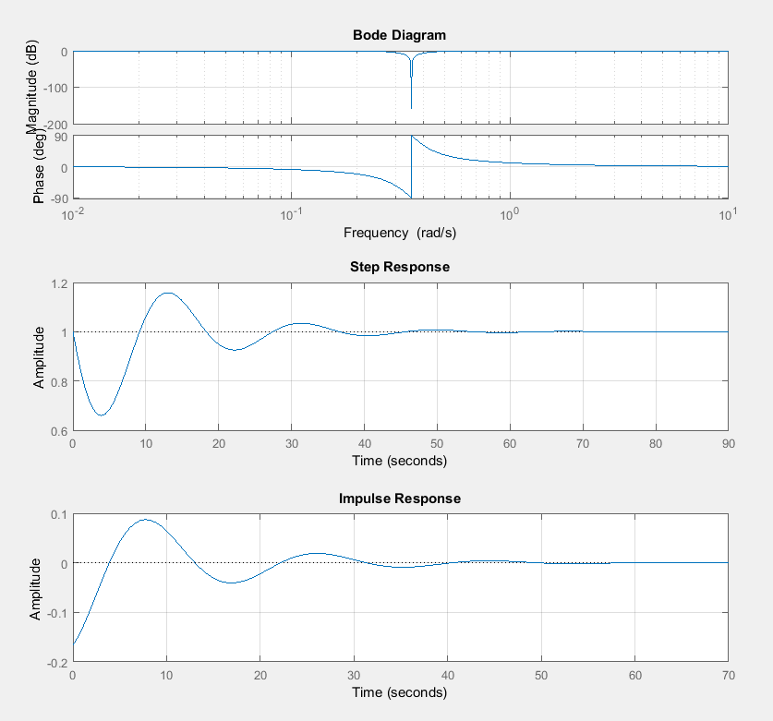

num = [24 0 3];

den = [24 4 3];

sys = tf(num,den);

subplot (311)

bode(sys)

grid on

subplot (312)

step(sys)

grid on

subplot (313)

impulse(sys)

grid on

**Task 2**

**Question#1**

num = [1 8 23 35 28 3];

den = [1 6 8 0];

[z,p,k] = residue(num,den)

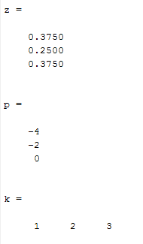

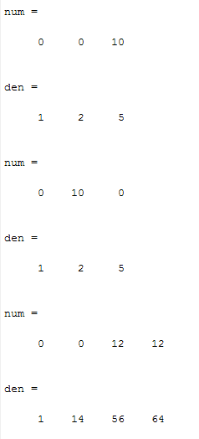**Question#2**

**(a)**

z = [];

p = [-1+2j -1-2j];

k = 10;

[num,den] = zp2tf(z,p,k)

**(b)**

z = [0];

p = [-1+2j -1-2j];

k = 10;

[num,den] = zp2tf(z,p,k)

**(c)**

z = [-1];

p = [-2 -4 -8];

k = 12;

[num,den] = zp2tf(z,p,k

**Question#3**

z = [-1; -2];

p = [0; -4; -6];

k = 5;

[num,den] = zp2tf(z,p,k)

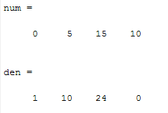

**Question#4**

num = [10 60 80];

den = [1 14 68 130 75];

[r,p,k]= residue(num,den)

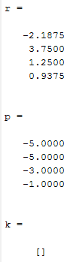

**Question#5**

num = [1 5 6 9 30];

den = [1 6 21 46 30];

[r,p,k]= residue(num,den)

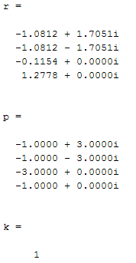

**Task 3**

**Question#1**

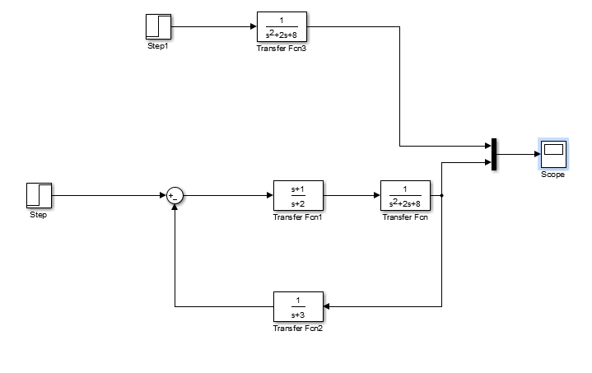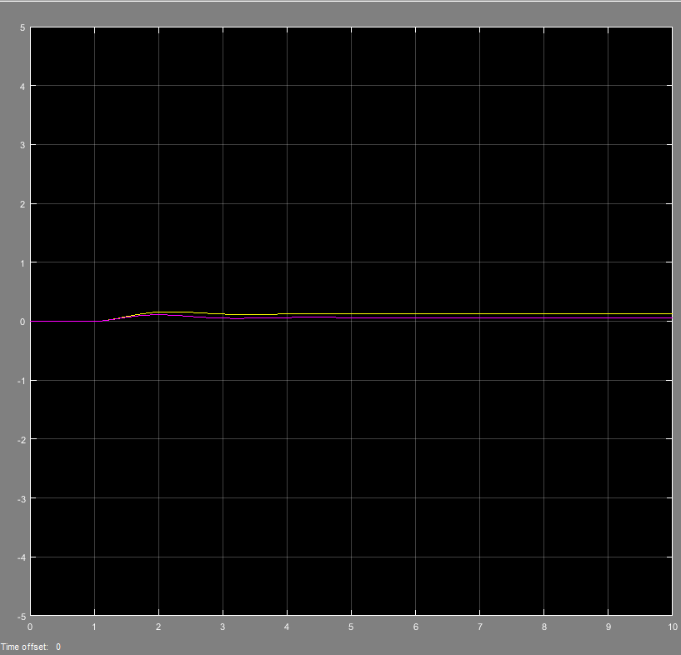

**Question#2**

